- Unprecidented Growth
- Population growth in South Carolina is: Unqualified to make a choice

- Population growth in Aiken Couty is DETRIMENTAL

  - Aiken has large swaths of land zoned as Rural District (RUD), a category which allows almost any land use to be intermingled with any other land use, whether or not they are compatible.
  - As a result, public infrastructure is being stretched beyond its limits, be it the transportation network, public water utilities, or the electric grid.
  - When the public has a chance to publicly voice its opinions about the impact of the growth on their personal lives and economic wellbeing it is overwhelmingly negative. One only needs to attend Legislative Delegation, City or County Council, or Planning Commission meetings to hear the outrage and anguish when projects developed largely out of the public eye come up for public comment prior to critical votes.
  - The County’s growth is caused disruption across the county but has failed to improve the economic lives of its lower income residents.
    - This snipped from the 2014 plan shows that 14% of County Residents were living in poverty in 2000:
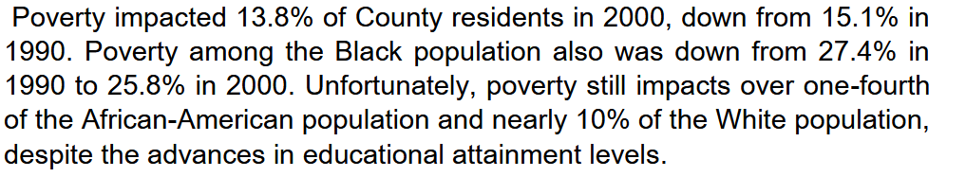
    - The 2014 Comprehensive plan has poverty at 14% and the Census Bureau reports that 14% of persons living in Aiken in 2024 were still living in poverty
    - Unfortunately, the 2024 data seen below, and displayed at a Public Information Session for the 2024 Comprehensive plan, showed that slightly less than 30% of household earnings were at or below the poverty level. This information mirrors that from the SC Ready tests of elementary school students which shows 30% of ACPDS third graders are classified as Pupils in Poverty. Note: 2024 Aiken poverty level for family of four is $31,240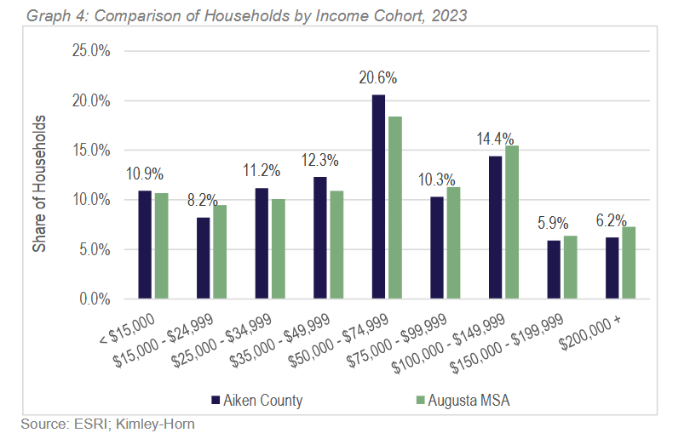
About 30% of families earn below poverty level
Further, a recent school board presentation to the Aiken Legislative Delegation revealed that about 30% of our students graduate unprepared for the work force.
The new plan must have a focus on improving our school system’s performance, and economic development recruitment efforts must focus on increasing job opportunities for less educated persons.
2. Growth has impacts; what has been and will be the most important impact.
  - Quality-of-life will continue to decline for the general public.
  - Natural environment will continue to be destroyed:
    - Aiken’s sandy soil is in the catchment basin for underground aquifers supplying local households, businesses, farms, and streams and rivers. Those same aquifers ultimately supply drinking water, and hold back seawater intrusion, for South Carolina’s coastal cities. The negative impact is both local and regional as consumptive uses of water increase.
    - Prime farmland, a key component of the South Carolina economy, will continue to be lost to other less productive uses – housing developments are not productive economic uses.
    - Natural areas for both recreational use by residents, and local and fly-over wildlife, will continue to be irrevocably lost
  - Many land owners will see the value of their land decrease (while only a few others will see it increase) as each new large industrial/commercial or residential project is brought to inappropriate parts of the county (i.e. prime agricultural, residential, or natural areas)
  - Large industrial/commercial projects, due to community opposition, will be crowded out by unconstrained and unmanaged growth of housing developments. This snipped from a Will Williams eMail related to Project Sunny is instructive in terms of infrastructure (and related recent discussions about impact fees), the impact of siting housing developments in close proximity to large commercial projects and comments in this document about sightline buffers. See the first sentence in the second paragraph related to the House of Rayford (HoR) And Shaw Industries):
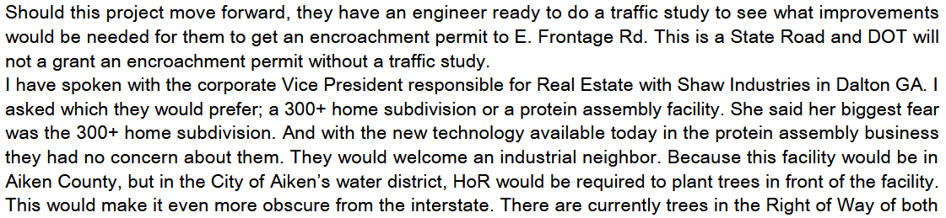….
  - Prime agricultural land, in the two bands that run through the county, will be lost as non-agricultural development continues in the RUD zone.

- How can the following institutions prepare for growth
- State of South Carolina
  - Take Legislative action to enable counties to:
  - Begin mandating that developers pay impact fees to cover at least a portion of the costs of addressing the surrounding community infrastructure burdens, be they to the electrical grid, water distribution utilities or transportation networks.
  - Begin charging for surface and ground water withdrawals large industrial/commercial enterprises. They are scarce resources. Increasing water’s cost will ensure that water’s use is as efficient as possible and encourage recycling.
  - Revise tax laws to means-test (i.e. gradually reduce the deduction as property value increases) deductions (School Prop Relief, Homestead Exemptions, etc.) available to homeowners and others.
  - Revise tax laws to provide more education resources for districts with the highest percentages of Pupils in Poverty and low achievement scores in critical early learning skills. Improvements in English and Math achievement in students’ early years will over the next 10 years will ultimately improve student graduation rates and readiness to enter the job market statistics.

- Aiken County Government
  - Ditto the above suggestions re State government, but at the local level
  - Abolish the RUD – Rural District – it is no longer adequate to the needs of the county.
    - RUD was assigned to mostly rural areas at the initial adoption of the LMO. Mistakenly RUD areas were deemed to not have a defined character, such as already existed in places like the Horse District. But, it did in fact have a defined character; it was rural with small towns, tree lined streets and roads, low development density, and small farms and commercial enterprises.
    - As the county’s population has grown, its citizens are no longer content with the ‘almost anything goes’ nature of the RUD zone and its tendency to allow incompatible uses to be sited side by side. Some areas, such as the newly-utilized RRC – Rural Residential and small Commercial – seek to retain Rural’s unique character. Other areas are also developing defined characters, such as those with the new housing developments that are springing up in an uncontrolled fashion. Yet, many current residents in the RUD zone do not want their neighborhoods disrupted. Their anguished pleas for relief from increase traffic and other disruptions, though heard by the Planning Commission, mostly go unanswered because the wide-open nature of the RUD classification ties the hands of the Commissioners.
    - With each new development or homestead created, other uses, for instance large scale agricultural or industrial or commercial projects, will progressively become untenable as they are forcefully resisted by nearby residents. Think of the reaction to Project Sunny.
    - There now already exist several zoning categories which more appropriately define broad swaths of the county. These areas are:
      - RRC for a majority of county’s rural areas,
      - Agricultural Preservation for the two bands of the county with the most fertile soil and,
      - Industrial Development designed to ‘protect and accommodate wholesaling, distribution, warehousing, . . .and is intended to protect for future development land with industrial potential’ for areas along major transportation routes such as I20 or Old 96 Indian Trail.
- Adjust salary scales to improve ability to recruit and retain the county staff needed to respond to the increasing demand for county services the growth is requiring. We are already seeing the positive impact of offering competitive salaries within the now fully-staffed emergency services area.
- Revise the Land Management Ordinance to require:
  - All new development should be required to shield the view of its buildings from roadways and neighbors. This will help retain the rural feel of driving down country roads that will continue to be lined with trees and shrubs
  - Permeable grass or gravel pavers in parking lots so as to facilitate aquifer replenishment
- Revise the County’s FILOT industrial/commercial recruitment efforts and FILOT enticements which have failed, for the last 24 years, to bring jobs to the county can employ our less-educated county residents and help lift or families and students living in poverty
      - Poverty rates have remained at 14% since 2000 despite two intervening periods of extremely low unemployment
      - The FILOTS reduce potential tax revenue to the county and more importantly the school district.
      - Unfortunately, the just-completed population survey of the county conducted to provide input to this new planning effort shows that just under 30% of Aiken’s households earn less than the poverty level for a family of four. This is a statistic mirrored in the 2024 SCReady English testing report for 3rd graders which shows that 30% of those students were Pupils [living] in Poverty (PIP).
      - Just as disturbing is the recent School District report to the Legislative Delegation that 30% of our graduating seniors are not prepared to join the workforce.
      - Incentives to bring in more jobs to the county should more often be directed at companies with occupations requiring less-skilled workers.
- Aiken County School District
  - The school district believes it has prepared as much as possible for future growth with its four big building projects funded by the new 1% sales tax.
  - It should also begin preparing for other impacts of growth by building into its annual budget a larger infrastructure maintenance and improvement component. The 1% sales tax is focused on new construction. The district has a huge backlog of deferred maintenance. As growth continues, the district will increasingly be relying on aging infrastructure to meet its needs.
  - Analysis of elementary school performance data indicate that equal educational outcomes are not being achieved across the district. Revising its funding formula to allow more intensive instruction in certain schools will eventually increase testing performance and lead to improved numbers of students being job ready upon graduation.
- Local business Community
The County should not be prescribing how businesses should be preparing for growth. As slower and appropriately managed growth provides shifting business opportunities, enterprising local businesses will respond as appropriate for their operations.
- Local Development Community
  - This group of businessmen should begin to include in their profitability calculations the cost of upgrading the infrastructure their developments will impact.
  - These developments should begin to include in their profit calculation the cost of including in their projects set asides of land for landscaping that preserves and/or restores the largely rural look and feel of the county. This would include riparian, sound, and light buffers between adjoining properties, waterways and roadways. Some portions of Whiskey Road exhibit this kind of softened sightlines, whereas others exhibit unsightly development close up to the road with no landscaping that softens the visual impact.
- Local non-profit organizations
  - Given that multiple sets of data, including that shown during the public information sessions, show that approximately 1/3 of county families live in poverty, they should expect the need for health and social services to increase, especially as it is also anticipated that these services will continue to be poorly funded by the state and county.
  - More efforts should be undertaken by organizations to support workforce development by strengthening or developing volunteer-supported:
    - Elementary education programs which help improve English and Math skills in the schools (tutoring, mentoring, etc.)
    - Participation in job training programs for our high school students. This is not to say the district does not have such programs, but data suggests they are not sufficient to provide skills marketable in our county, or to lift families out of poverty.
  - More affordable housing is needed in the county. These types of organizations should be looking for creative models to fund the development of permanent or temporary housing for our large and growing population of low-income or homeless persons.

- Rank the following areas according to their importance
8__Adequate infrastructure | 5__Natural Resource Management
2__Farmland preservation | 1__Neighborhood Preservation
6__Health Care Availability/Options | 10_Parks and Recréation
7__Housing Affordability | 9__Traffic Congestion/Delay
3__Housing Availability/variety | 4__Workforce Development

1. Neighborhood preservation Farmland preservation Housing Availability/Variety
4. Workforce Development Natural Resource Mgt Housing Affordability
7. Health Care Availability/Options Adequate Infrastructure Traffic Congestions/Delay
- Parks and Recreation

These categories do not lend themselves to a simple numerical scoring. Some are equally important.
- The three areas on the top line below the table need to be improved simultaneously and with similar importance. These categories generally will help retain the rural and small-town character of the county. Building up congested commercial corridors such as we have on Whiskey Road and to a lesser extent around the Silver Bluff / Pine Log area detract from that character.
- Those in the second line generally support successfully addressing those in the first line
- It is hoped that Items on the bottom two lines will naturally develop in appropriate areas as a consequence of activities preserving neighborhoods, farmland and natural resources.

- Additional Comments

  - As one of the new Implementation Plans, define a process aimed at bringing more visibility into early planning for any large industrial or commercial project being recruited into the County. As the failed Project Sunny has shown, the Aiken City and County Councils seem to have an unbridled thirst for new commercial development. That a project for which there was insufficient infrastructure, mostly incubated behind closed doors, could move through multiple reading stages in both chambers before being voted down, clearly indicates the need for economic recruitment and development process change. The implementation strategies portion of the Plan must address this issue. As mentioned elsewhere in this document, clearly defining areas for future expansion of industrial operations inform landowners of areas that might not be suitable for residential expansion.

  - Unequal impacts of growth – Opportunity Zones

    - The impacts of growth have not been felt equally across the county. As I’m from Windsor, I generally observe conditions in Aiken City and the smaller towns of Perry, Wagener and Sally. In other volunteer work I regularly pass through North Aiken.

    - In Windsor, the influx of retirees associated with equine activities has resulted in the recent addition of two new businesses, one is called the ‘department store’ (Dollar General) and the other is a locally-owned coffee shop/luncheonette which is an expansion of a business located in New Ellenton. Both are in the historic town center of Windsor. Unfortunately, nearby Wagner, Perry and Sally and other similar old established towns have had their centers hollowed out.

    - Meanwhile Whiskey Road has at times become a traffic nightmare and spreading housing developments are destroying some of the county’s best potential farmland.

    - The North Aiken area is a center of poverty for our county; the North Aiken Elementary school in 2024 had 85% of its 3rd grade students identified as Pupils in Poverty.

    - This plan needs to identify where and how it will address the persistent poverty in that area. Its housing stock needs upgrading, job opportunities need to be increased.

    - Areas most in need of stabilization and growth should be identified as additional Economic Opportunity zones or their equivalent. They should be given as much favorable economic assistance as possible (perhaps overlay districts with a revitalization objective need to be created). I’d go so far as to say such areas should have negative property tax rates to incentivize new development.

  - Retain our rural environment
The county has many pastural and forested areas which are necessary for the replenishment of the aquifers beneath us. In the short term they provide plentiful clean water not only for our homes by also for our farms and riparian systems. In the long term aquifers in Aiken, which stretch to the coast, provide fresh water there and help prevent salt water from intruding into coastal city drinking water sources.

  - Support small town commercial cores – Town centers
I lament the decline of the Mayberry-ish small towns that dot the area around my rural neighborhood. But as we look at their hollowed-out cores, we should also see the ring-like development structure around them. As you drive into many small towns around our area you will transition from a rural area with large and small landholdings, into an area of smaller lots and close-in housing. Next you pass the larger homes of the wealthier merchant-class, and then arrive at the commercial core. This development model developed without any formal zoning. However, our development environment has changed. The Comprehensive Plan should envision zoning that replicates that ring-like structure around concentrated commercial cores. Gone are the railroads, but the crossroads and other needed infrastructure are already there. This model should allow multifamily structures – up to quads and perhaps even low-rise apartment buildings. It’s a model discussed favorably with the new Development Manager five or more years ago - at the start of the first discussions about creating what is now the RRC zone. It is still a viable planning strategy and economically beneficial development model. It increases housing density thereby enabling the creation of more affordable housing.

  - Inhibiting Industrial Development
    - Unbridled large housing development increasingly constrains development of adjacent land that might be better suited to industrial or large-scale commercial development

  - Streetscapes
    - To retain the look and feel of a rural area, by requiring landscaping buffers that provide sight, sound and light moderation around properties. Views of buildings as seen from roadways should be screened to retain the rural character of the non-urban areas. Driving along State Park Road and other rural roads you see that, unless there are large pastural areas (be they agriculture- or horse-related), many residences and farmsteads are not visible from the main road – this nature of the community should be retained, even on industrial or large commercial operations.

  - Donut Holes in Aiken City should be eliminated, at least so there are not gaps in infrastructure such as sidewalks and curbs.

  - Permeable gravel or grass pavers
As we are the catchment basin for local and coastal aquifers, reduce the amount of impervious surface being created in the county. Require that all newly installed parking areas and driveways have permeable pavers such as the as the grassy one already found in one of the parking areas at Hopeland Gardens

- Optional Information

  - Resident of Aiken: Yes
  - In City Limits of Aiken or North Augusta: No
  - Zip Code: 29856
  - Age: over 70
  - Number in Household: 2

